SPOTIFY CLONE

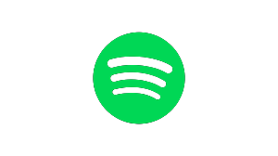

**GROUP MEMBERS:**

**19SW16 - SHAHZAD PANHWAR**

**19SW121 - POOJA KUMARI**

**19-18SW115 - AHSAN SHAIKH**

**ABSTRACT**

Spotify is the biggest music streaming service in the world, and with more than 400 million active monthly users, the service isn't showing any signs of stopping. It recently released a new AI DJ feature in beta that learns your listening habit and scans new releases to play songs you will like or take you back to old beloved playlists you've forgotten. With this new release, Spotify music recommendations will become even better. With the endless songs that the service offers, you can explore different music genres and listen to artists across the world.

### Here is Spotify Clone, that is easy to use and provides a tailored listening experience. Now it is available on the web platform. It allows sharing music experience and gives access to the massive music library.

**ISSUES ENCOUNTER:**

* Javascript validation
* Issues faced while using choosing user interface
* Icon size
* Button navigation

**USER GUIDE:**

**For setup:**

You have to install Visual Studio Code and run the folder, open with visual code.

You have to debug or just press F5 to run it on Browser

**[VS CODE SS]**

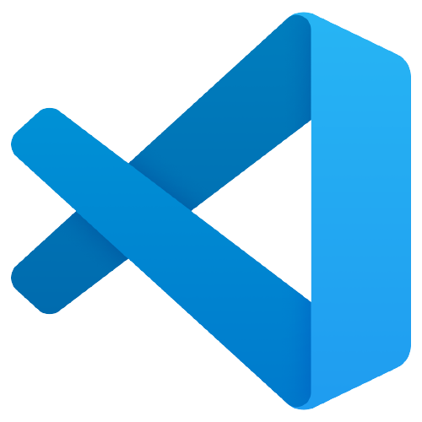

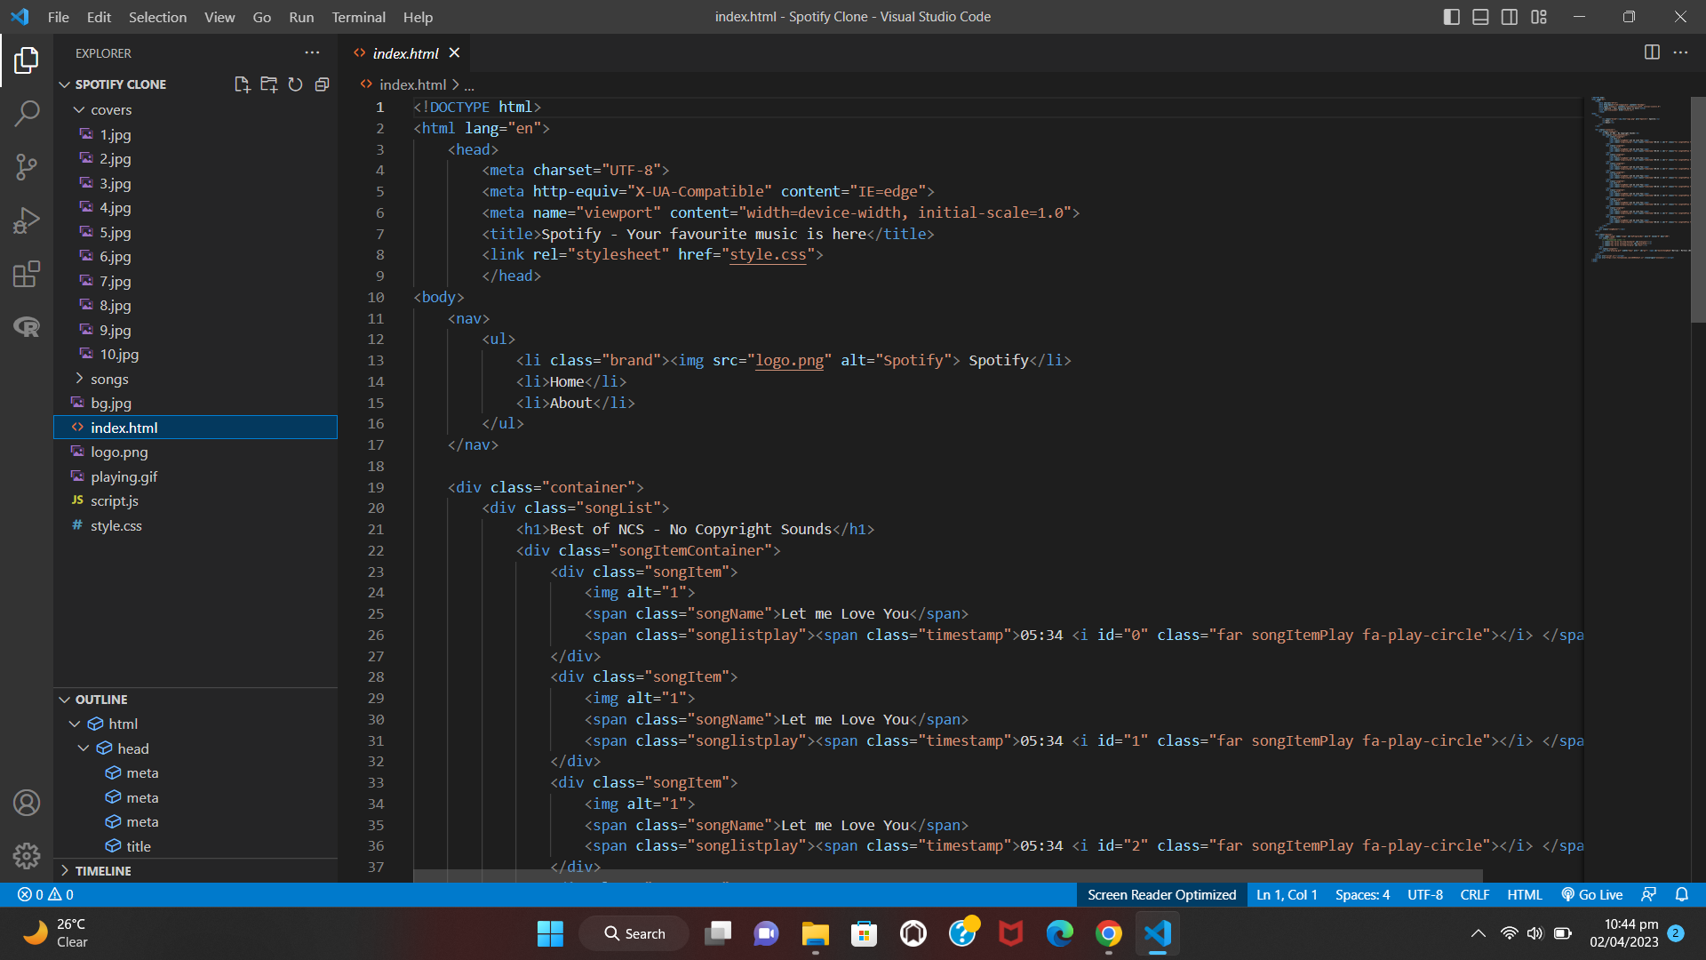

**How to play Spotify web Clone:**

* Tap on the song that's playing to access the full playback menu; you can pause, use the arrows to skip songs, randomize your song selection and add a loop.

**[WEB SS after running project]**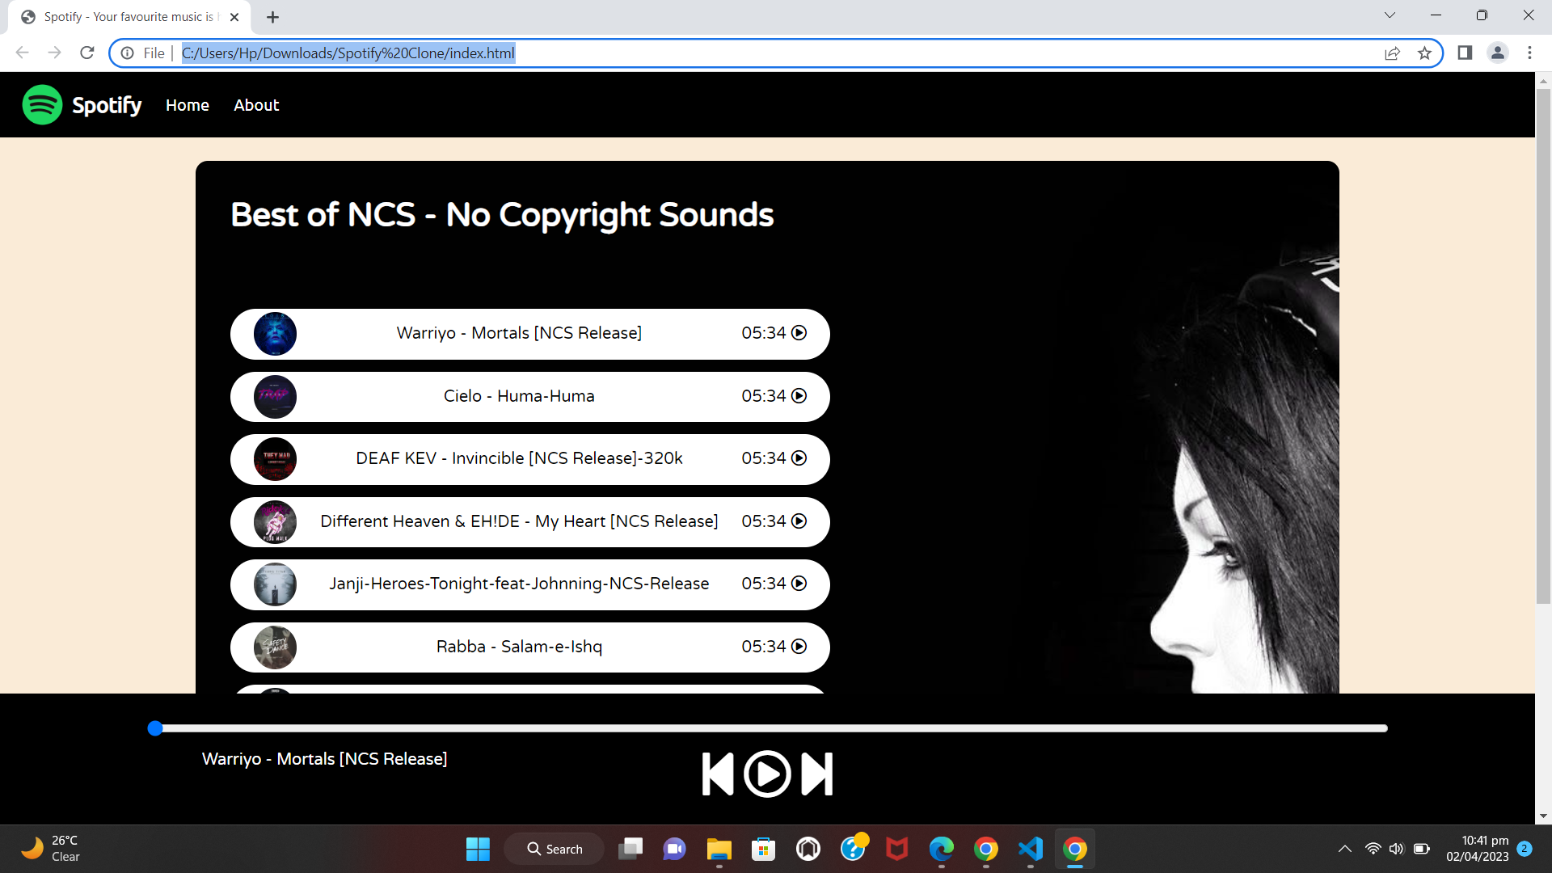

**[After playing]**

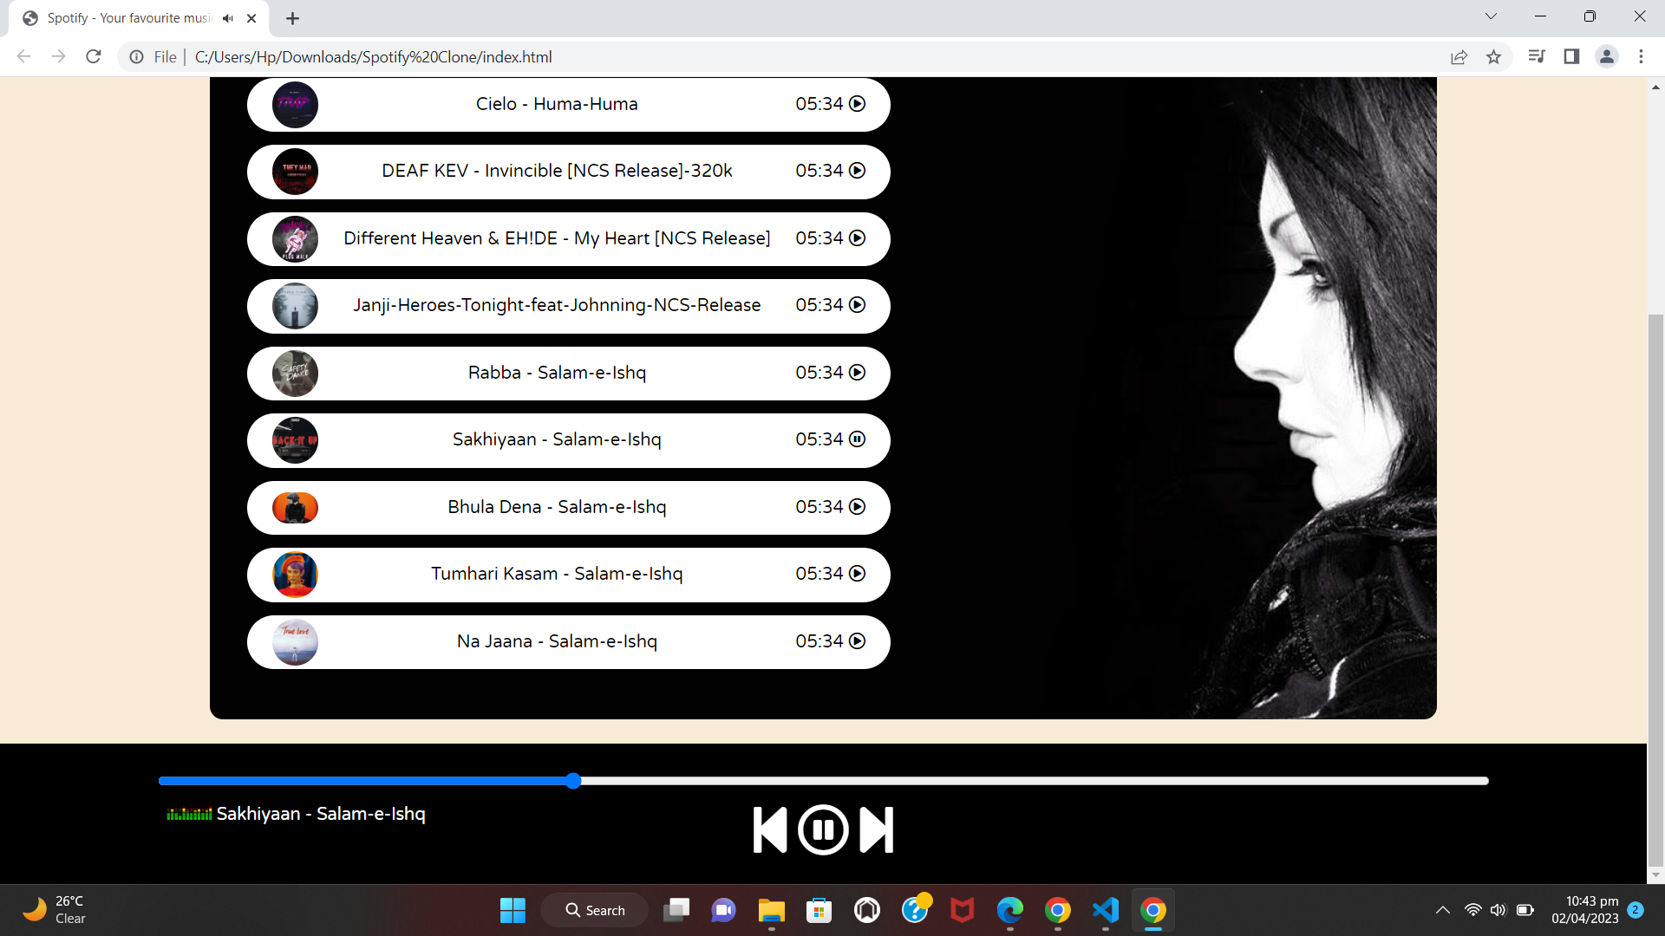

**[Playing graph]**

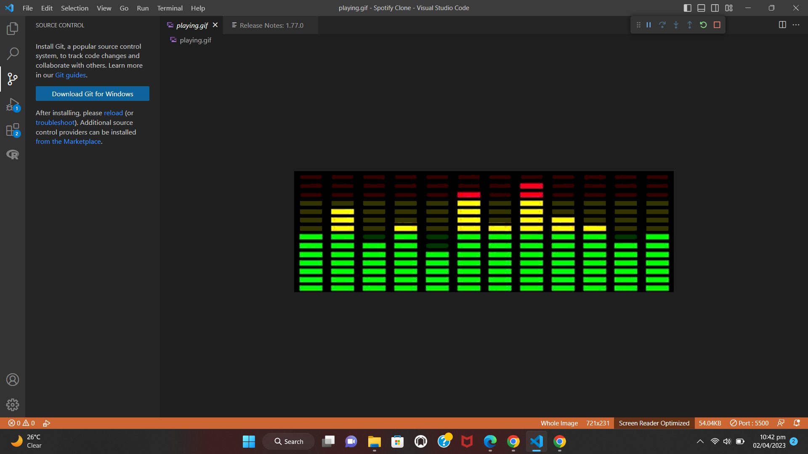

Spotify users listening to music on their computer can put their music on repeat or shuffle with two buttons. These buttons act as **toggle buttons, pressing them will turn the setting on or off**. The shuffle button can be on or off. The repeat button has two states, repeat all and repeat one.

